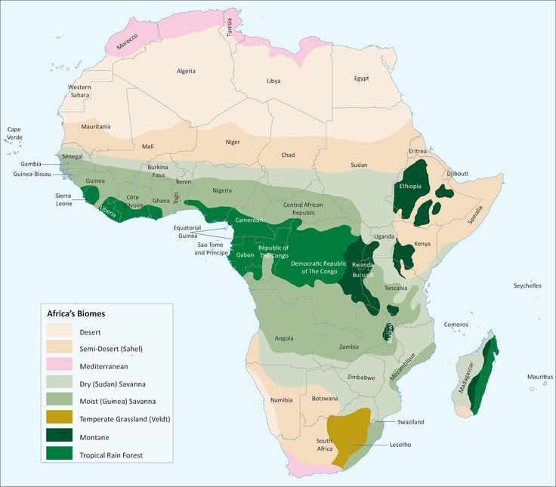
CLIMATIC REGIONS IN AFRICA

